**Credit Card Fraud Analysis**

**Q.1. List 5 data points that are required for the analysis and detection of a credit card fraud.**

1. Transaction Amount – Helps identify unusually large or small purchases.
2. Timestamp (Date & Time) – Detects unusual transaction times or rapid repeated transactions.
3. IP Address & Geolocation – Flags mismatches with the cardholder’s usual location.
4. Billing and Shipping Address – Helps spot sudden or suspicious address changes.
5. Device Information (Device ID, Browser, OS) – Detects logins or transactions from new or unfamiliar devices.

**Q. 2. Refer to the data table below and identify 3 errors/issues that could impact the accuracy of your findings.**

[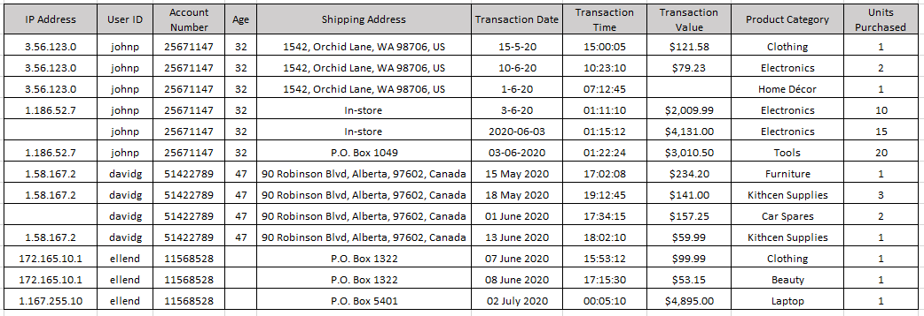](https://github.com/akanksha-ghadage/Learning-Exercises/blob/main/Q2.png)

1. The transaction on **01-06-2020 at 07:12:45** by user **johnp** shows a missing value in the **"Transaction Value"** column, making it difficult to analyse total spending.
2. The transaction on **01 June 2020 at 17:34:15** by user **davidg** and on **03 June 2020** at **01:15:12** by user **johnp** has a blank **IP Address**, which prevents location-based fraud detection.
3. The **"Transaction Date"** column includes inconsistent formats such as **“3-6-20”, “2020-06-03”** and **"01 June 2020"**, which can disrupt date-based sorting and trend analysis.

**Q.3. Refer to the data table below and identify 2 anomalies or unexpected behaviours, that would lead you to believe the transaction may be suspect.**

[](https://github.com/akanksha-ghadage/Learning-Exercises/blob/main/Q2.png)

1. **Unusually High-Value Transactions with Rapid Delivery Preference Changes (User: johnp)**: On 03-06-2020, user johnp made a transaction worth $4,131.00 and immediately afterward another one worth $3,010.50, both from different delivery methods ("In-store" and "P.O. Box 1049"). This sudden change in delivery preference combined with high-value purchases within minutes is highly irregular and may suggest account takeover or fraudulent behaviour.
2. **Multiple High-Volume Purchases from Same User and IP in Short Time (User: davidg)**: User davidg made four transactions from the same IP address (1.58.167.2) within less than a month, purchasing unrelated product categories like furniture, kitchen supplies, and car spares. The behaviour is inconsistent with regular shopping patterns and may point to automated fraud or testing stolen card details.

**Q.4. Briefly explain your key take-away from the provided data visualization chart.**

[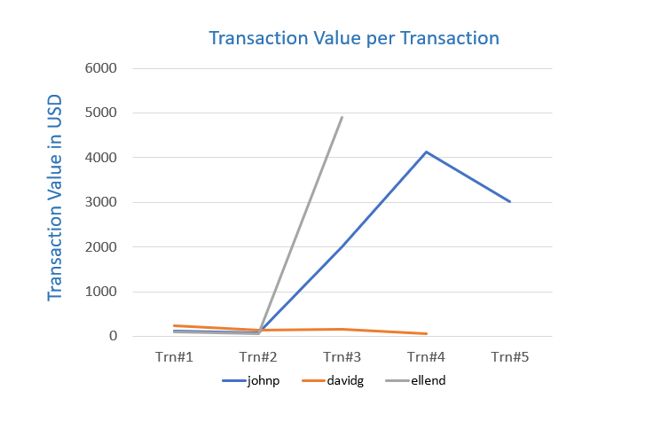](https://github.com/akanksha-ghadage/Learning-Exercises/blob/main/Q4.png)

The chart clearly shows that johnp and ellend have unusually high transaction values compared to davidg, whose transactions remain low and consistent. Specifically:

• johnp exhibits a sharp spike around Trn#3 and Trn#4 (above $4,000), indicating potentially fraudulent activity or abnormal behaviour.

• ellend also has a dramatic increase at Trn#3, reaching nearly $5,000, which is inconsistent with earlier low-value transactions—another red flag.

• In contrast, davidg shows stable and low-value transactions, suggesting typical user behaviour. This visual highlight suspicious spikes in spending that should be further investigated for possible credit card fraud.